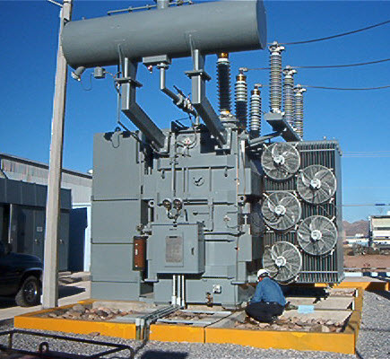

|  |  |
| --- | --- |
| System | **TX 01 Main Power Transformer** |
| Aim | **Electrical-Offline Aim** |
| Site or Area | **Substation 101** |
| Location | **Bay 201** |
| Equipment Condition | **Offline** |
| Instructions | The tasks listed in this document are to be carried out while the equipment is offline. |
| Special Notes |  |
| Hazards | Pinch Points, Tripping & Slipping Hazards, Ergonomic Issues |
| Permits and Isolations | Job Hazard Assessment or Safety Risk Assessment.  Refer to site Lock-Out/Tag-Out and Isolation Procedures. Always make sure that all energy sources have been controlled, released and isolated before starting work on the equipment.  Always make sure your supervisor knows where you are working or what equipment you are servicing. |
| Personal Protective Equipment (PPE) | Standard Site PPE |
| Other Safety Equipment |  |
| Tools | Standard Trade Tools |
| Materials |  |
| Resources | 2 Electrical |
| References | [Example Equipment Manual.txt](G:\\Programming\\EngineersTools\\WinWriter\\Equipment Manuals\\Example Equipment Manual.txt) |
| Prepared By | Your Name Goes Here |

|  |  |
| --- | --- |
| WIR - Wiring Inspection | |
| TASK | DESCRIPTION |
| 1 | Visually inspect HV and LV terminal boxes, gaskets and internal connections. |

|  |  |
| --- | --- |
| FUN - Functional Tests | |
|  | |
| TASK | DESCRIPTION |
| 1 | Function test low oil level alarm. |

|  |  |
| --- | --- |
| FUN - Functional Tests | |
|  | |
| TASK | DESCRIPTION |
| 1 | Function test the Oil Temperature Indicator and Winding Temperature Indicator alarm and trip points.  If transformer is Forced Air cooled, set the fans to "Auto" start. |

|  |  |
| --- | --- |
| BUCH - Buchholz Relay Inspection | |
|  | |
| TASK | DESCRIPTION |
| 1 | Inspect the condition of the Buchholz relay. Inspect the state of the gas accumulation window. |